
NATIONAL SKI PATROL Date prepared:

133 South Van Gordon, Suite 100
Lakewood, CO 80228-1706

NOMINATION
NATIONAL SKI PATROL 50 YEAR SIGN

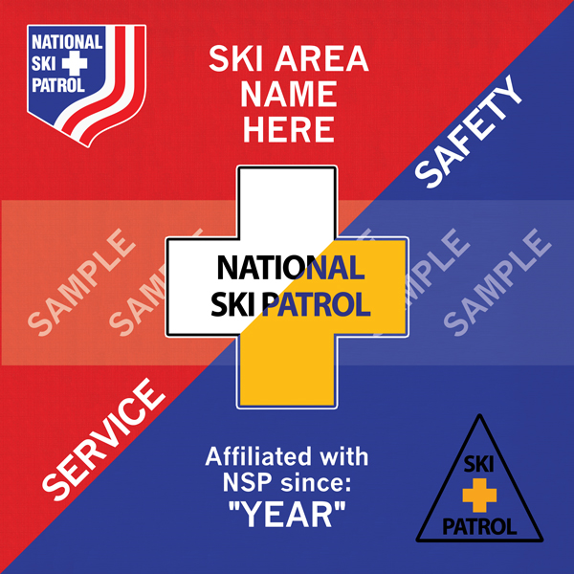

1. |  | Patrol’s Name: |  |  |  |  |  |  |  | Patrol NSP ID: |  |  | #
2. |  | Ski Area’s Name:
3. |  | Year Affiliated with NSP: |  |  |  |  | Region: |  | Division:
4. Send this award to: |  |  |  |  |  |  |  |  |  |  | Date Needed:
 | Mailing Address:

ACKNOWLEDGMENTS Printed Name & Member ID Signature Date Signed
NSP Patrol Director/
Representative
Region Director
Division Awards Advisor
Division Director/Designee
National Awards Adviosr

TEMPLATE INSTRUCTIONS: Use this template to apply for a National Ski Patrol 50 Year sign for a patrol affiliated with NSP for 50 or more years. This template is typewritten and the font size should not be smaller than 9 point. Submit this template as the original .doc file format and ALL other supporting artifacts (such as scanned .PDF signature pages) to the applicable review/approval officers in accordance with local Division Policy.

NOTE: This template is “protected” to prevent alteration and to preserve the structure and format integrity. The .doc file extension is backward compatible to MS Office Word 97-2003. If file protection is disabled, enable it again before submitting to the Approval chain. DO NOT change any template field structure/format/titles or file extensions.

• Date prepared: The date the submission is prepared by the Sponsor.
(Date prepared format = Mmm DD YYYY) Example: Mar 09 2020

• Public Posting Date: The date the National office makes the award publicly visible in the recipient’s National profile Awards section. (Public Posting Date format = Mmm DD YYYY) Example: Mar 09 2020

Section 1-2 – Fill out sections accurately. Do not use nicknames.

Section 4 – Fill out ALL info fields in the “Send this award to” section with a Name, Mailing Address and the Date Needed. At least 45 days prior to award presentation is required for processing.
(Date Needed format = Mmm DD YYYY) Example: Mar 09 2020

Mailing Address: Because the National office uses the UPS for their shipments, all mailing addresses MUST be a valid physical residence address. NO PO boxes. The ONLY EXCEPTION are APO, FPO and DPO customers as these shipments MUST be handled via the US Postal Service.

ACKNOWLEDGMENTS CHAIN. When signing/dating the nomination form, the chain vouches for the validity of the nomination. (Date Signed format = Mmm DD YYYY) Example: Mar 09 2020

• The cost of the sign is: $150.00 | Make checks payable to: “NSP Awards Program”

• To pay by credit card, the National Office will call you. Please provide the following contact information:
Name: Phone number:

